ELEC1601

Group 34

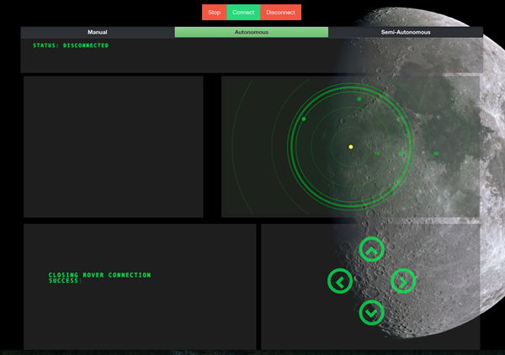

Name SID UNIKEY

Brett Findlay

Ryan Kang 430417630 jkan6341

Sam Cheng 460358253 sche6190

Louis Li 450264005 LOLI0102

# Introduction

The purpose of this project was to design and create a prototype that involves the use of two Arduino Uno boards and a robot connected with sensors and actuators with the ability for bi directional communication via Bluetooth shields.

## Description

Our final prototype is based off the functionality of a Roomba (Robot vacuum) and a Rover used for space exploration. The prototype will be able to navigate to its surroundings without the need for user intervention with the ability to also display obstacles and the path it has taken to reach its current position over a web interface via Serial and Bluetooth communication.

## Use Scenario

By adding extra component such as vacuum, the robot can clean a house automatically or manually through the control of a user.

The robot can also use to create a map in area human cannot enter (moon, toxic area etc). This allow plan to be made before entering the area (building or research).

# Final Representation

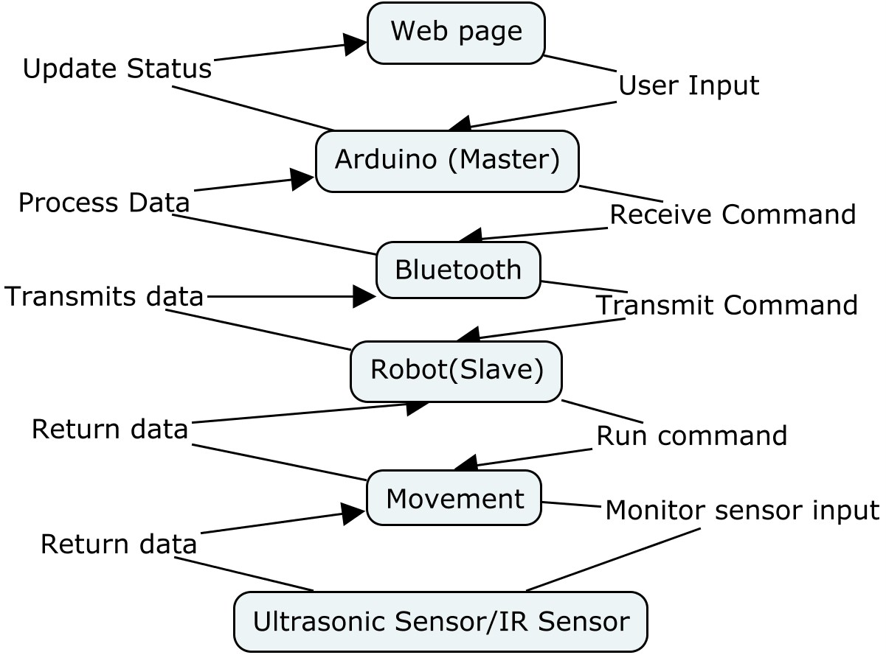

## CMAP Diagram

CIRCUIT DIAGRAM

Do it in Fritzing

Implementation

# Project Management

## Task Division

|  |  |  |  |  |
| --- | --- | --- | --- | --- |
|  | Brett | Ryan | Sam | Louis |
| Week 7 | Research ideas | Research ideas | Research ideas | Research ideas |
| Week 8 | IR & Bluetooth | IR & Bluetooth | IR & Bluetooth | IR & Bluetooth |
| Week 9 | Bluetooth Communication | Bluetooth Communication | Bluetooth Communication | Bluetooth Communication |
| Week 10 | Webpage processing of Bluetooth data | Avoidance of IR Code | Avoidance of IR Code | Avoidance of IR Code |
| Week 11 | Webpage processing of Bluetooth data | Robot Movement | Robot Movement | Webpage processing of Bluetooth data |
| Week 12 | Finalise on project | Finalise on project | Finalise on project | Finalise on project |

## Progress

### Week 7

On the first week of the project, our team discuss about what we want to do for our project. After the discussion our team decided to create a robot that can record surrounding obstacles and plot it on to a map.

### Week 8

Week 8 we were introduce to bluetooth and ir sensor. After seeing the new component our team decide to create a manual and automatic mode. The manual mode allow the user control the robot through bluetooth real time and the automatic mode lets the robot to move and avoid obstacle itself. However the bluetooth shield given during the lab was faulty hence we will have to work on it in week 9 and work on simple movement such as turn left and move forward this week.

### Week 9

Due to week 8 we did not have a working bluetooth shield, our team focused on implementing the bluetooth shield with the movement code written in week 8. At the end of the lab we were able to control the robot through bluetooth by typing command on Arduino monitor.

### Week 10

On week 10, our team wanted a better way to control the robot. So one of our member was assigned to create an interface on a webpage to control the robot. The rest of the member worked on implementing how the robot will avoid obstacle.

### Week 11

Our team was close to finish during week 11, half the team continue to improve the web-page interface and bluetooth communication for the robot, and half the team continue to write code for the robot’s movement and ways to avoid obstacle.

### Week 12

On the last week, our team mainly discuss about how to present our robot and test the robot is running the way it should.

# Flow Chart Representation of code

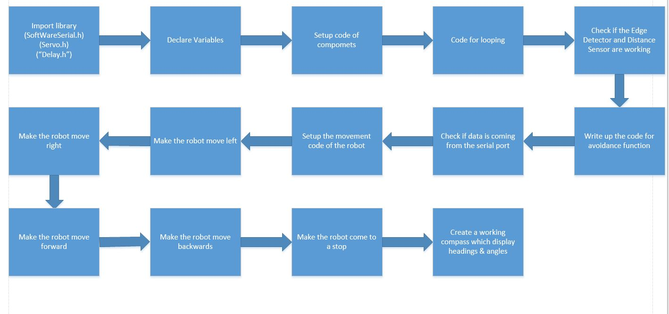

# Pseudo-code

## Setup

Include Libraries (SoftwareSerial, Servo, Adafruit_Sensor, Adafruit_HMC5883_U)

Setup all output and input pin

## Loop

Check the mode of the robot

If the mode is auto, run automatic movement else run manual movement.

## Automatic Movement

If there is an obstacle in front,

look to the left then right to obtain the distance of obstacle from left and right

move back

If the distance on the left is greater, Then turn left, else turn right

Else if there is edge, then turn left.

Else move forward.

## Manual movement

Read command from user then run it.

(Command include: move forward, turn left, turn right, move backward, get distance and change mode)

# Organisation of code

Our team used a github repository to store all our code. At the end of each week’s lab, we upload the code implemented in the lab. Also if we want to prepare code to test for the next lab, we also upload the code to the repository.

Screenshot:

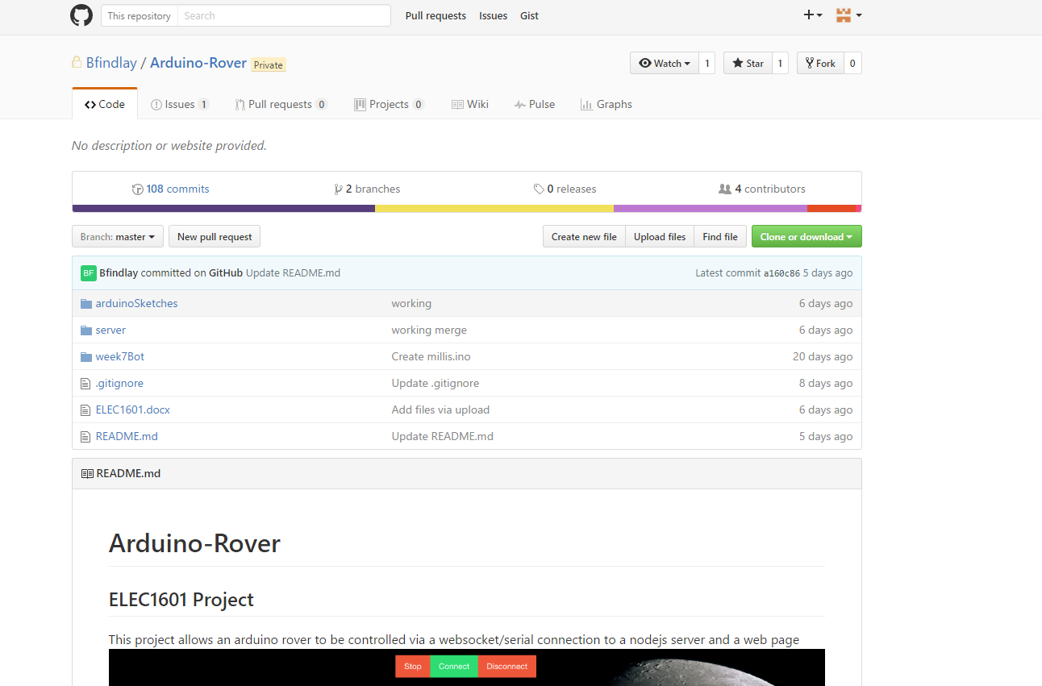

# Description of the final prototype

The robot is controlled by using the interface implemented on a webpage. On the interface, user can change the mode of the robot (manual or automatic), see the map with the path of the robot travelled and the obstacle detected by the robot and control the robot using keyboard keys when the robot is on manual mode.

Screenshot of interface:



# References

**Robot Idea:**

http://mars.nasa.gov/msl/multimedia/interactives/learncuriosity/index-2.html

http://science.howstuffworks.com/mars-rover4.htm

http://electronics.howstuffworks.com/gadgets/home/robotic-vacuum2.htm

http://homesupport.irobot.com/app/answers/detail/a_id/2087/~/how-does-roomba-700-work%3F

http://spectrum.ieee.org/automaton/robotics/home-robots/irobot-brings-visual-mapping-and-navigation-to-the-roomba-980

**Sensor:**

http://www.tautvidas.com/blog/2012/08/distance-sensing-with-ultrasonic-sensor-and-arduino/